Exhibitor Registration Form
Special offer available for limited Booths

- Exhibitors’ Details:

Contact Person
Organization
Designation
Office Address

City
Email
Website
Mobile
Telephone

- Business Segment you belong to (Please tick all that apply)

Tour Operator
Travel Agencies / Online Travel Agent
Resorts / Hotel / Motel
Cruise lines (Domestics International)
Airlines (Domestics International)
Coach / Bus Operators / Car Rentals
Online Reservation System
Travel Association
National Tourism Organization (NTO)
Tourism Skills Institute / University
Community Tourism Organization (CBT)
Health and Wellness, Adventure & Sports Tourism
Other (please specify)

- We will confirm your booths as per availability (Pls mentioned Hall no. and booth no. as discussed)

Hall #02
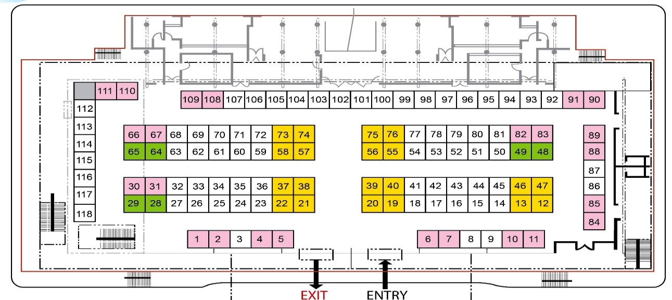

Hall #5
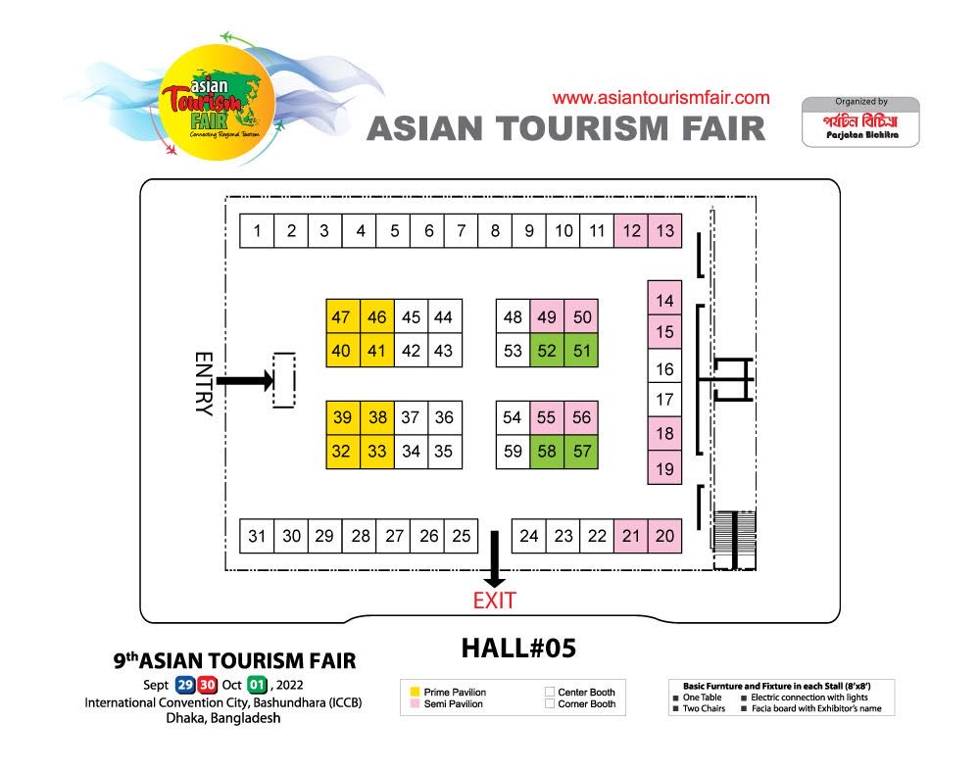

- How big space do you need for exhibiting ATF-Dhaka?
Exhibitor’s Offer:

AC Booth Sized | Regular Rate | Special offer
(8ft X 8 ft) = 64 Sft (Standard Booth) | USD. 1500.00 | USD 1200.00
(16ftX8ft) =128 Sft. (Semi Pavilion- Corner Booth) | USD. 3000.00 | USD 2400.00
(16ftX16ft) =256 Sft. (Pavilion- Corner Booth) | USD. 6000.00 | USD 4800.00
Above Amount Includes (every unit of stalls): Basic Shells, 2Tables 2Chairs # Fascia with Company Name # 1 Basket # Light & Power Socket.
Please Note: VAT (15%) not included in the above rate.
AC Standard Booth (8X8) sft = 64 sft
AC Semi Pavilion (16X8) sft =128 sft
AC Pavilion (16X16) sft = 256 sft
AC Pavilion (32X8) sft = 256 sft

- Total Payable Amount.

- Are you interested to join B2B Session?
(Free for Buyer, registration basis only)

Yes
No
- Are you interested for Destination/ Product Presentation session?
(1 Hour Session in Seminar Hall with payment USD 500)
Yes
No

- Payment to
You may transfer Payment directly to this Account. | Account Name: | Parjatan Bichitra
 | Account Number: | 005311100000598
 | Bank Name: | Southeast Bank Limited
 | Branch Name: | Sat Masjid Road Branch (Dhanmondi, Dhaka 1219, Bangladesh)
 | Branch Code: | 0053
 | Swift Code: | SEBDBDDHXXX
Your immediate payment is highly appreciated.

Note:

- Your organization detail will be published in fair Directory.
- Concern Department will contact you as per interest as above.
- Activation Team will contact if requires any logistic support for Fair.
- Reservation will be confirmed after receiving payment.
Return this form to ATF Secretariat by email -

- info@asiantourismfair.com
- asiantourismfair@gmail.com

- Reservation from:

Name
Designation
Organization
Mobile no.

